(NOT SO) SCI-FI ENERGY ALTERNATIVES | Draft Date: 05/6/17 | Draft or Revision Number: 1

AUDIO | ASSET/SHOT
GRAPHIC
(NOT SO) SCI-FI ENERGY ALTERNATIVES

FADE TO
1. Nuclear Fusion
VOICEOVER:  In the 1950s everyone thought an atomic car was just around the corner. | A happy 50s guy is driving along in his 1956 Edsel. At the back it has a small canister with an atom sign on it. He’s driving into a city which has a sign “WELCOME TO ATOMIC CITY”  Around the corner of an intersection comes another similar car.
VOICEOVER:  What held this idea back—other than safety…  SFX  Metallic tink. | The cars crash lightly at the intersection and stop.  PULL BACK as they explode in a huge nuclear blast which levels blocks.
VOICEOVER:  was the search for the Holy Grail of future-energy generation: Nuclear Fusion. | A scientist holds up a holy grail-like cup which is labelled NUCLEAR FUSION?
VOICEOVER:  How to mimic the atomic reaction which occurs at the center of the sun in a small, controlled, way? | The sun’s atomic reactions.  PULL BACK into space.
VOICEOVER:  Today, researchers have developed a compact fusion reactor which offers clean energy, no nuclear sludge— | A proud scientist, like this man, with a Lockheed Martin compact reactor (as in this example).  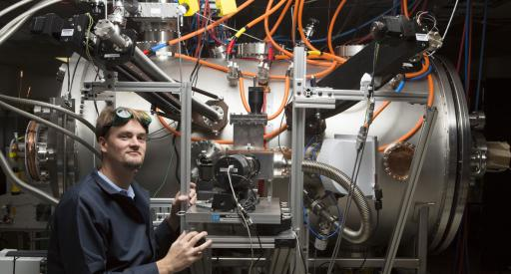
VOICEOVER:  and could one day safely power homes or even cars. | A modern suburban street. Each house has a small reactor outside. Day turns to night and the lights flicker on.  A woman pulls into a driveway in a modern Mini-Coupe. It has a small canister/reactor with an atom symbol on it.
GRAPHIC

2. Deep Geothermal
VOICEOVER:  In Jules Verne’s sci-fi classic Journey to the Center of the Earth, there were dinosaurs dwelling underground. | A cross-section of the earth as a tunnelling steam-punk vehicle moves down to the earth’s core.  In a cavern, the vehicle stops and some people get out. A Tyrannosaurs jumps out at them, roars and they run back inside.
VOICEOVER:  Unlikely. 99.9% of the Earth's core has temperatures over 1,000 degrees Celsius. | A real cross section showing temperatures, such as.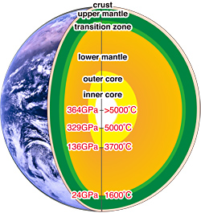
VOICEOVER:  There IS high-pressure water, steam and hot rocks. Deep Geothermal looks at viable ways to drill deep and tap this energy. | A rig worker is drilling an exploratory hole into the ground using heavy machinery.  Steam comes out.
VOICEOVER:  It’s renewable, available day and night, and promises no pollutants. The answer might be right under our feet. | He’s standing at the edge of the hole looking down.
GRAPHIC

3. Space: The Final Frontier
VOICEOVER:  How did Capt. Kirk power, or even get a signal on his space communicator? | Captain James Kirk shoots at some aliens and gets out his phone-communicator. He looks down—it shows only one bar.
VOICEOVER:  Space-based energy technologies could be the answer. | He holds the phone up high and walks around looking depressed.
VOICEOVER:  Harvesting hydrogen from the moon to power fuel cells on Earth? | A tractor with a guy in a space suit is ploughing up the ground on the moon. In the sky glows the earth.
VOICEOVER:  Orbiting solar arrays that absorb sunlight and beam the energy back down to stations on the ground?  NASA and other orgs are currently researching exactly these kinds of technologies. | An array of satellites in space above the earth unfold solar panels which begin absorbing light from the sun.  PAN around a satellite. It has a big NASA logo on it.
VOICEOVER:  The future might not be so far off as you think. Find out at the 2017 Future Energy World Expo. | Close on Expo logo and contact details.

